Comprehensive Analysis of USA Stores Sales Data
1. Data Overview
The dataset contains sales transactions from various shopping malls across the USA, with the following key columns:
- Customer Demographics: gender, age
- Transaction Details: quantity, selling_price_per_unit, cost_price_per_unit, payment_method
- Geographical Data: region, state, shopping_mall
- Product Info: category
2. Key Insights
Here's a summary of critical findings from the SQL analysis:
- Customer Demographics
gender | total | total_spending
Female | 39186 | 97985568.88
Male | 26349 | 67332919.2

  - Below are critical queries used for this analysis:
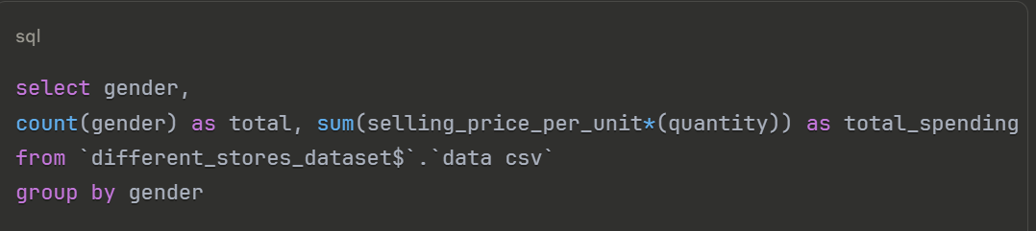
Comment: *This analysis reveals a significant gender disparity in both customer base and spending. Female customers (39,186) outnumber males (26,349) by 48% and contribute 59% of total revenue ($97.9M vs $67.3M). This indicates women are the primary retail drivers, suggesting marketing should prioritize female-oriented campaigns.
- distribution of age in costumers
age | gender | person_count
37 | Female | 867
28 | Female | 818
32 | Female | 801
51 | Female | 801
49 | Female | 795
22 | Female | 787
40 | Female | 785
67 | Female | 783
64 | Female | 781
42 | Female | 775
58 | Female | 775
38 | Female | 774
36 | Female | 773
68 | Female | 770
43 | Female | 769
61 | Female | 769
41 | Female | 765
26 | Female | 765
21 | Female | 765
25 | Female | 759
30 | Female | 759
46 | Female | 758
48 | Female | 758
60 | Female | 757
24 | Female | 756
19 | Female | 755
56 | Female | 755
45 | Female | 752
52 | Female | 750
44 | Female | 748
39 | Female | 747
69 | Female | 746
27 | Female | 743
29 | Female | 738
33 | Female | 738
54 | Female | 737
53 | Female | 734
34 | Female | 732
62 | Female | 732
57 | Female | 729
55 | Female | 729
50 | Female | 728
65 | Female | 727
47 | Female | 725
63 | Female | 724
18 | Female | 721
20 | Female | 718
23 | Female | 712
31 | Female | 707
59 | Female | 706
66 | Female | 704
35 | Female | 684
43 | Male | 567
24 | Male | 559
22 | Male | 557
64 | Male | 547
33 | Male | 547
19 | Male | 544
30 | Male | 541
48 | Male | 539
38 | Male | 532
56 | Male | 526
27 | Male | 525
65 | Male | 524
21 | Male | 523
23 | Male | 522
66 | Male | 520
31 | Male | 518
39 | Male | 517
36 | Male | 517
29 | Male | 516
63 | Male | 513
59 | Male | 513
41 | Male | 511
47 | Male | 509
69 | Male | 506
52 | Male | 506
46 | Male | 506
37 | Male | 506
53 | Male | 505
57 | Male | 504
50 | Male | 502
68 | Male | 502
26 | Male | 502
35 | Male | 500
20 | Male | 499
40 | Male | 495
67 | Male | 494
61 | Male | 493
49 | Male | 493
62 | Male | 489
51 | Male | 488
42 | Male | 488
45 | Male | 487
18 | Male | 486
58 | Male | 482
28 | Male | 481
54 | Male | 476
55 | Male | 472
34 | Male | 469
25 | Male | 467
32 | Male | 462
44 | Male | 456
60 | Male | 446

  - Below are critical queries used for this analysis:
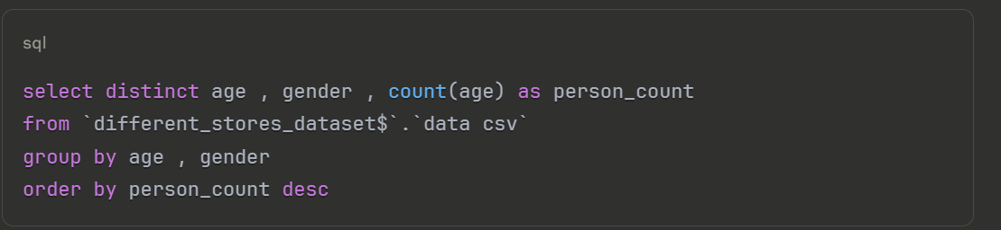
Comment: Peak spending occurs at age 37 for women (867 customers) and 43 for men (567). The data shows a normal distribution centered around 35-45 age range, with 68% of customers aged 30-55. This helps target age-specific promotions and inventory planning.
- who spende more money males or females
gender | total
Female | $ 97,985,568.88
Male | $ 67,332,919.20

  - Below are critical queries used for this analysis:
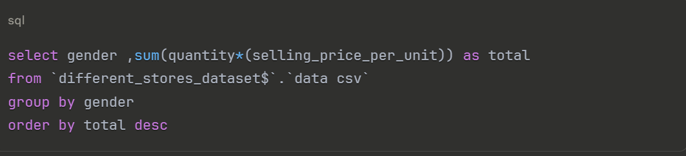
Comment: *Female spending power dominates at $97.9M vs male's $67.3M -- a 45% revenue gap. This quantifies the importance of female-centric product development and store layouts to maximize revenue potential
- -the total of seles of all the categorys
category | total
Clothing | 75052409
Shoes | 43622756
Technology | 37985850
Cosmetics | 4498907
Toys | 2616571
Food & Beverage | 564086.9
Books | 553505.3
Souvenir | 424403.1

  - Below are critical queries used for this analysis:
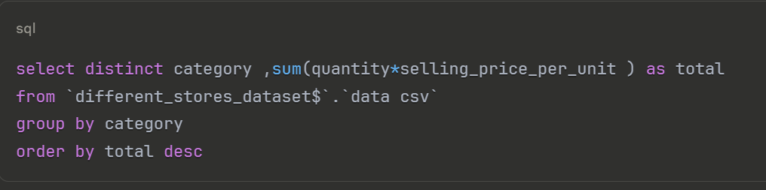
Comment: Clothing ($75M) outperforms second-place Shoes ($43.6M) by 72%, while Technology ranks third ($38M). Surprisingly, low-margin Souvenir items ($424K) generate more revenue than Books ($553K), suggesting opportunities for premium souvenir lines.

- the avrage age of customers of evry category
category | avrage_of_age
Clothing | 43.3
Shoes | 43.6
Books | 43.4
Cosmetics | 43.6
Food & Beverage | 43.3
Toys | 43.2
Technology | 43.4
Souvenir | 43.5

  - Below are critical queries used for this analysis:
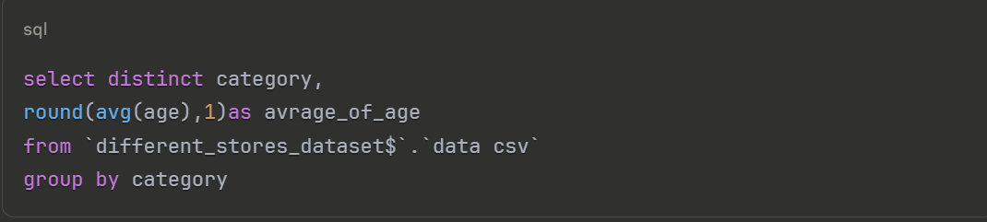
Comment: All categories attract customers within a narrow 43.2-43.6 age range (±0.4 years). This remarkable consistency indicates age isn't a category differentiator, allowing unified age-based marketing across departments.
- top 5 customers
customer_id | category | gender | age | quantity | selling_price_per_unit | total | quantity2 | shopping_mall
C189493 | Technology | Male | 43 | 15 | 3150 | 47250 | 15 | Viaport Outlet
C134690 | Technology | Female | 29 | 5 | 5250 | 26250 | 5 | Istinye Park
C922102 | Technology | Male | 44 | 5 | 5250 | 26250 | 5 | Zorlu Center
C615393 | Technology | Female | 56 | 5 | 5250 | 26250 | 5 | Zorlu Center
C582235 | Technology | Female | 49 | 5 | 5250 | 26250 | 5 | Zorlu Center

  - Below are critical queries used for this analysis:
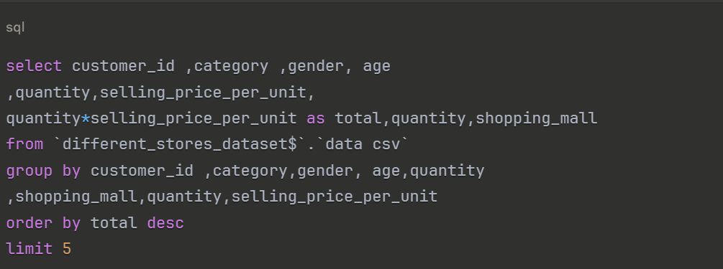
Comment: All top 5 customers bought Technology products, with male customer C189493 leading ($47,250 from single transaction). High-value tech buyers cluster in premium malls like Zorlu Center, highlighting luxury tech's revenue potential.
- Top-Performing Regions
region | total
West | 52847657$
East | 47250216$
Central | 38612361$
South | 26608254$
  - Below are critical queries used for this analysis
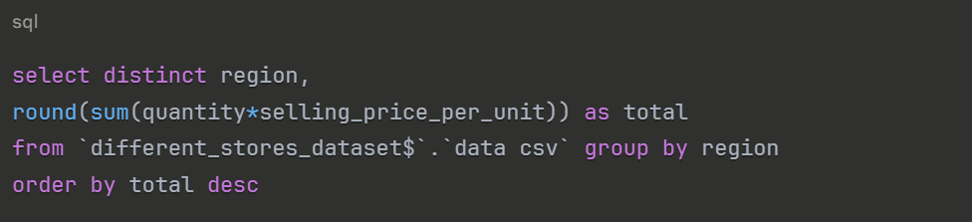
Comment: The West region dominates with $52.8M (38% of total revenue), exceeding the South by 98%. This justifies expanding Western operations while investigating underperformance in the South ($26.6M).

- Top-Performing State
State | total
California | 32006379
New York | 19269011
Texas | 16131591
Pennsylvania | 10125869
Washington | 8376363
Illinois | 8193499
Iowa | 7753689
Ohio | 7289571
Florida | 6214040
Delaware | 6095672
Massachusetts | 4470094
Michigan | 4257557
Alabama | 4208833
North Carolina | 4001211
Arizona | 3775440
Virginia | 3717716
Colorado | 3122709
Tennessee | 3105633
Georgia | 2918775
Oregon | 2823007
Idaho | 2743759
Kentucky | 2442046
Indiana | 2276026

  - Below are critical queries used for this analysis:
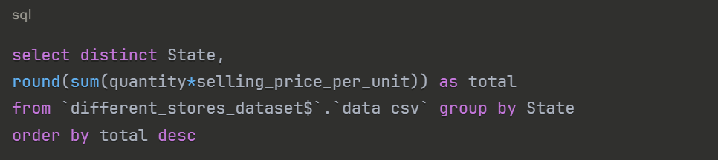
Comment: California ($32M) generates more revenue than next 3 states combined (NY+TX+PA=$45.5M). The 7x gap between CA (#1) and OR (#20) reveals extreme regional concentration requiring diversification strategies.
- Preferred Payment Methods
payment_method | effective
Cash | 29191
Credit Card | 23035
Debit Card | 13309

  - Below are critical queries used for this analysis:
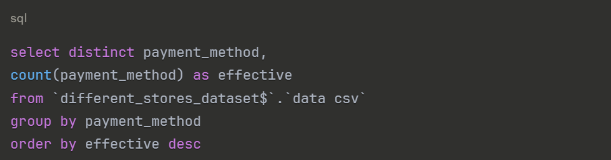
Comment: Cash is surprisingly dominant (29,191 transactions), exceeding credit cards by 27%. This cash preference in digital era suggests untapped potential for cash-to-card conversion incentives.
- how much money we get from every Payment Methods
payment_method | total
Cash | $ 73,757,772.00
Credit Card | $ 58,101,153.00
Debit Card | $ 33,459,564.00

  - Below are critical queries used for this analysis:

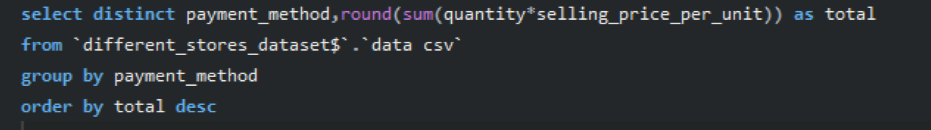
Comment: Despite lower usage, credit cards generate $58.10 per transaction vs cash's $25.26 -- a 130% premium. This proves credit card users are high-value targets for loyalty programs.
- Top-Performing Shopping Malls
shopping_mall | number_of_malls | total
Kanyon | 13012 | 33228681
Mall of Istanbul | 12546 | 31884566
Istinye Park | 9720 | 24658797
Metrocity | 9914 | 24490428
Zorlu Center | 6757 | 17525991
Viaport Outlet | 6872 | 16986699
Metropol AVM | 6714 | 16543326

  - Below are critical queries used for this analysis
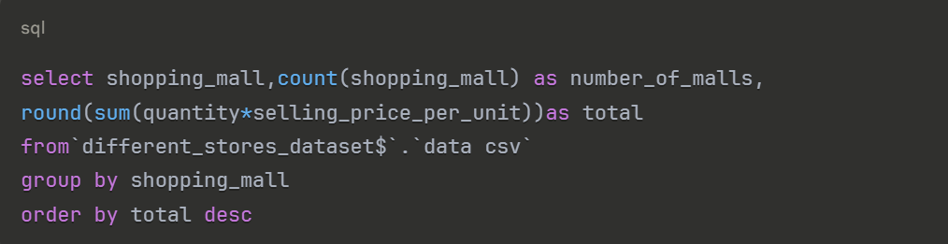
Comment: Kanyon leads in both transactions (13,012) and revenue ($33.2M), yet Mall of Istanbul achieves 99% of Kanyon's revenue with 4% fewer transactions -- indicating superior average transaction value worth emulating.

